Bruschetta Chicken
Prep Time 10 min Cook Time 15 min
4 Servings
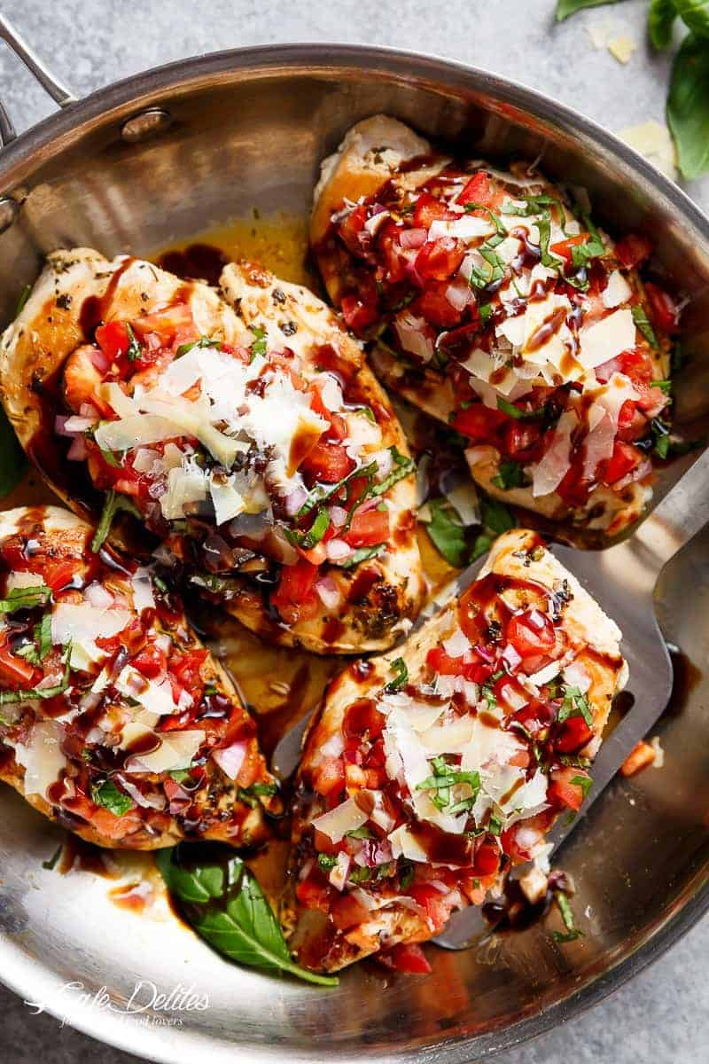
Ingredients
4 boneless skinless chicken breasts
3 tsp Italian seasoning
2 tsp minced garlic
1 tbs of olive oil
4 Roma tomatoes, finely chopped
¼ of a red onion, finely chopped
3 cloves garlic, finely chopped
4 tbs shredded fresh basil
2 tbs olive oil
½ cup freshly shaved parmesan cheese

Balsamic Glaze: (you can use store bought, or this recipe)
½ cup balsamic vinegar
2 tsp brown sugar (optional)

Directions
- Season chicken with Italian seasoning, garlic and salt. Heat oil in skillet, and sear chicken breasts over medium-high heat until browned on both sides and cooked through (about 6 minutes each side). Remove from pan. Set aside and allow to rest.
- Combine the tomatoes, red onion, basil, olive oil in a bowl. Season with salt. Top each chicken breast with the tomato mixture and parmesan cheese.
- Serve immediately with balsamic glaze.
For the Balsamic Glaze
Combine brown sugar and vinegar in a small saucepan over high heat and bring to the boil. Reduce heat to low; allow to simmer for 5-8 minutes or until mixture has thickened and reduced to a glaze. (If not using brown sugar, allow to reduce for 12-15 minutes on low heat).
Notes
If you don't have Italian seasoning, use Italian dried herbs or combine 1 teaspoon dried oregano, 1 teaspoon dried basil, and 1 teaspoon dried parsley together.
You can buy pre-seasoned Italian Perdue chicken

